Project Design Phase-II Technology Stack (Architecture & Stack)

|  |  |
| --- | --- |
| Date | 20 October 2022 |
| Team ID | PNT2022TMID01280 |
| Project Name | Project-Real-Time Communication System Powered by AI for Specially Abled |
| Maximum Marks | 4 Marks |

Technical Architecture:

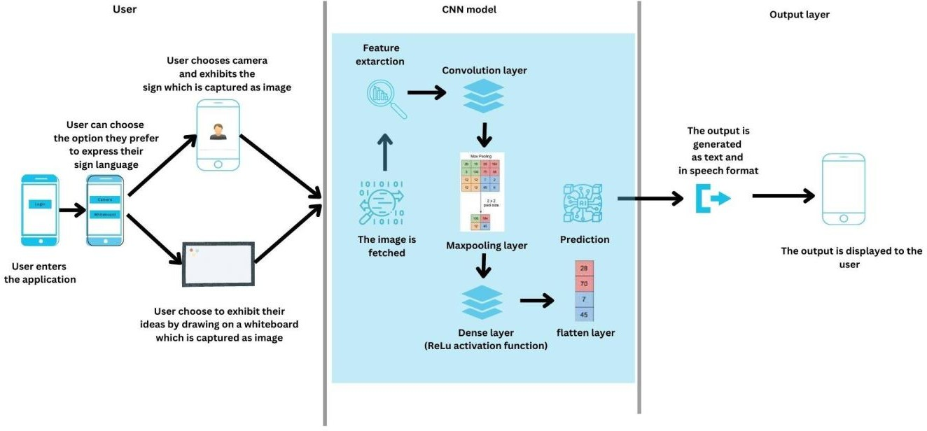

Table-1 : Components & Technologies:

|  |  |  |  |
| --- | --- | --- | --- |
| **S.No** | **Component** | **Description** | **Technology** |
| 1 | User Interface | User Interface provides options for the user to either upload a photo or turn on live camera for the prediction of sign language | HTML, CSS,  JavaScript/React JS |
| 2 | Application Logic-1 | The user input is taken and passed on to the model for feature extraction and prediction of the sign language. | Python |
| 3 | Application Logic-2 | The output is produced in speech format using the IBM Watson Text To Speech service. | IBM Watson TTS service |
| 4 | Database | The user login details and credentials are stored and processed using MySQL database. | MySQL. |
| 5 | Cloud Database | We use IBM cloud data storage to store and manage user data. | IBM DB2, IBM  Cloudant etc. |
| 6 | Machine Learning Model | Our Machine learning model is used to predict sign language with precision and accuracy. | Hand gesture recognition, etc. |
| 7 | Infrastructure (Cloud) | Our application is deployed using IBM Watson services | IBM watson services |

Table-2: Application Characteristics:

|  |  |  |  |
| --- | --- | --- | --- |
| **S.No** | **Characteristics** | **Description** | **Technology** |
| 1 | Open-Source Frameworks | Flask web application, Google colab | * HTML * CSS * Javascript * Flask * Google colab |
| 2 | Security Implementations | User login credentials and other details will be secured Using MD5 encryption and IAM Controls. | MD5, Encryptions, IAM Controls, OWASP etc. |
| 3 | Scalable Architecture | This project enables the developer to add more templates and it also paves the path to train the model in-case if there is a need to train the model with new sign language. | Technology used Machine learning |
| 4 | Availability | This is an open source application and it is available to all users and it manage all the customers without any network glitch | Technology used Flask web application |
| 5 | Performance | This app will quickly upload and process the images because it predicts the sign language using CNN model and it gives high accuracy. | Technology used |